SECURE PORTAL FILE TRANSFER SYSTEM:
Presented by:
M Adil Usmani L1F22BSCS0399
Hassan Siddiqui L1F22BSCS0378
Hurr Ali Syed L1F22BSCS0362

Introduction & Literature Review:
The problem was that the University Portal was failing to provide a safe transfer mechanism for files and information between various entities of the system like faculty, admin, HOD, and others. The need was for a system to introduce strong mechanisms for encryption and decryption and safe transfer and sharing of information. Also, unauthorized access and lack of audit and authentication were issues we addressed by having Role Based Access Control (RBAC) on files. We implemented a centralized secure system which uses modern algorithms like AES-256 and RSA-3072 for main encryption and decryption across the system and used Argon2id for password hashing.
The system is built on zero trust architecture, i.e., the system assumes everyone is hostile and trusts no one and enforces strict mechanisms of security for everyone regardless of their role. The objective here is to ensure that, first, only the HOD of any department can decrypt a file, access it, and download it, and that only the HOD of the department of the faculty who uploaded it has access to it. Along with that, it provides proof that messages have not been altered with in the internal mechanics of the system.
The objective here is to ensure that confidentiality and integrity of the system and data are maintained while availability is also ensured; hence, the triad principle of CIA is implemented. The system also uses role based and department scoped routing logic, which keeps in check who downloaded what data and whether they were allowed to do so, even if the system already prevents this in its features.
The system uses standard architecture and a tech stack by implementing algorithms like AES-256, RSA-3072, and Argon2id for security while using FastAPI for backend routing, SQLAlchemy for data management and database, and Pydantic to ensure proper input validation while using Streamlit for the UI of the system. It also uses proper techniques in terms of the user interface to implement error handling and checks and handles the majority of edge cases which a user may encounter to ensure robustness of the system.

Methodology:
In the design of the system we did not relied upon one algorithm or approach rather we used a variety of layered production in order to have the flow of the system as we desired and as the user expects it to be like if the user wants to create an already created username he wont be able to , if the user does not pass the validation checks that require the username to be a certain way and the password of the system to be a certain way ( like having small and capital letters and numbers etc ) he wont be able to register , if an account does not exist it cant login if say the user tries wrong password for a number of times the system will get locked out and like if the role condition is not done correctly like a person comes and tries to be HOD of a faculty which already has an HOD it wont allow as the HOD of a department has a max and minimum value of 1.
We used mainly two algorithms for file transfer we used AES and RSA we used AES for secure encryption and we used RSA for secure key transport of AES so , one was used for like high and heavy bulk data and the other mainly used for transport of secure key to relevant destination. Also we used SHA ( SHA-256 & SHA-512 ) to see the integrity of data and to confirm that files, messages and other information is not modified or has not corrupted during the transfer, receiving, decryption and storage of the data.
In database we used SQLAlchemy as the main database but upon addition of one field or any changes in the database we would have to delete the database and reconfigure it which was not a very optimal or efficient approach hence we solved this by migrating to Alembic which helps in that aspect and does abstraction for a lot of the database stuff. It tracks changes in the data models and updates databases without losing existing database stuff. Also in input validation we ensure the validation of certain inputs to a certain type i.e department will always be a string etc.

Architecture:
Frontend:
We used streamlit for secure and presentable front end and as explained above we implemented checks for the maximum number of head of department, validation for user names and checking for existence of said new user and password and validation of length and complexity of the password and that it satisfies the requirement of the architecture. We also implemented 4 main categories of the frond end at first we have we
LOGIN/SIGNUP page with all validation and other requirements for a user to login or register and uses Argon2id for hashing of those input. After successful login we have the
UPLOAD FILE mechanism in which the user can select to whom to send the file and what type of file and can upload files from the system and the validation present in terms of size that max size of upload can be 10 mb and the type of files can only be of certain extension only. And upon successful upload it shows that file is sent successfully.
Other than that we have the messaging system which has inbox messages , sent message and send message which essentially implements an inbox of the messages anyone sent you and displays the content of messages and sender and similarly in sent messages it shows the messages sent by the user to someone and its details and in send messages shows to the user a dialogue box to write a message and send it to a person using a drop down bar to select the contact to whom the message should be sent as you cant send a message to a user who does not exist in the system.

Backend:
The backend uses FASTAPI for asynchronous handling of all the coming requests. It implements all endpoints of the system that are called by the front end on same logic for login , message or file sharing mechanism but here we implement the actual hashing and encryption and decryption using the algorithms mentioned. For database we use SQLAlchemy with SQLite which helps manage the relational database which has users,department and other database fields.
There is isolation in terms of the files that faculty files are routed to the head of department of that faculty only and only that HOD has the key to decrypt and see and download the files sent by the faculty of his department. The files themselves are stored in encryption and not plain text.
ERD:
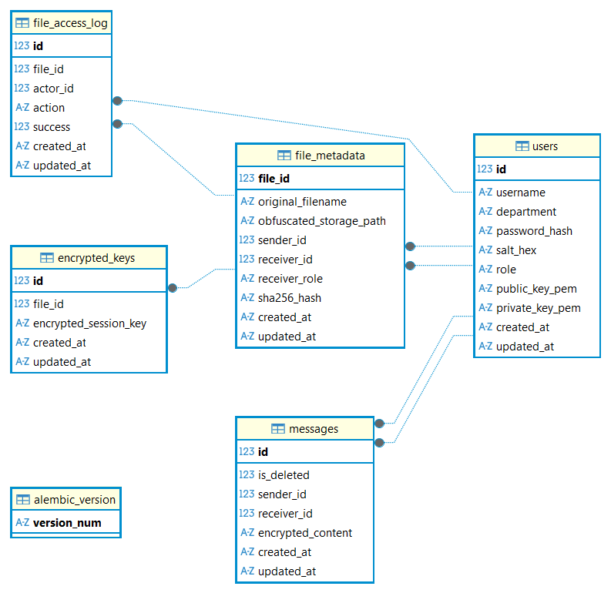

Query testing of Database:
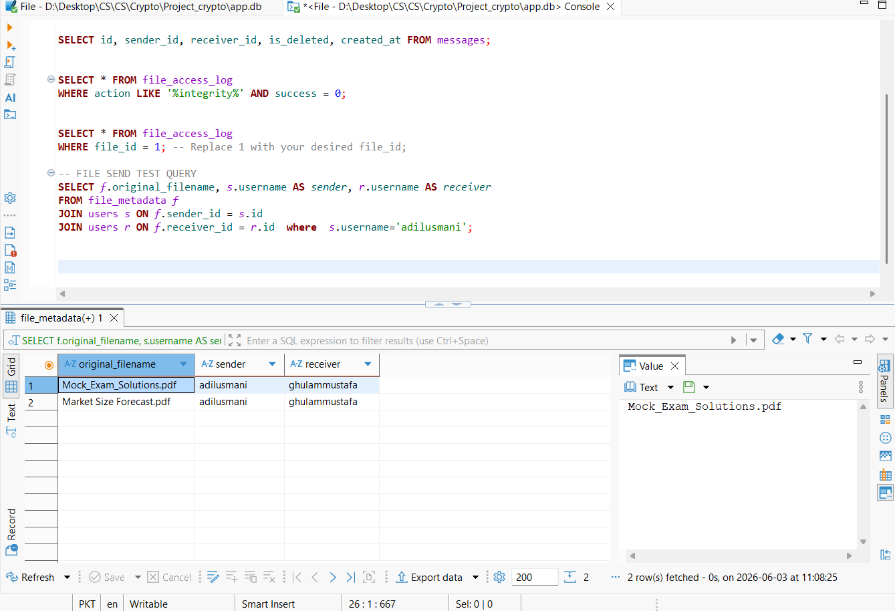

Challenges & Results :
Departmental Routing:
When the system was first built and it was tested for user it had a couple of issues which we had to address in order to have proper and full functionality of the system. Initially the system was not properly implementing the check that HOD and faculty should belong to same department in order for HOD to decrypt the file. The query was using a sequential method .first() which meant that the system would route all uploaded paper files to HOD who was first to register which would have access issues to other HOD and have leak of information across department and not even implement the 1 Department 1 HOD so it was replaced by a .one() query which implemented the rule we wanted and the leak was controlled hence we also enforced the department attribute to each user and also used it in the api routing logic so that the system now ensures that each files is sent and accessed by the HOD of that senders Department.

KEY ALLIGNMENT:
On first testing an issue happened that the backend was pulling the senders public key instead of receivers public key in the aes session key and this would mean that the file cant be decrypted as wrong keys were getting fetched for decryption. We solved this such that the systems uses the receiver_id variable . This ensured that the encryption and decryption would work as we desired and as the system required. So the majority of file is encrypted using aes and session key is wrapped for the recipient public key.

API Issue:
Initially the system relied on streamlit( ui side ) validation of checking of MIME types and malware scanning but this had an issue an actor could bypass this by hitting the backend api point directly and crash the system it was solved by changing all MIME logic, malware scans and other issues like this to backend so that the endpoint can perform autonomously and cant be crashed by bypassing the ui input. The code in files.py in router sub folder uses python-magic in order to check for these issues and checks the validation and security of data before it goes to storage disk.

Database Issue:
While developing the system whenever the schema required updates like addition of department column we had to manually delete the database file app.db then restart the application create users again and test the whole system again and we lost all data including meta data, user data, messages data upon every addition. To solve this we used Alembic to migrate and integrate new changes in the database without deleting existing database and data inside the database. By using Alembic we had a version based controlled database which helped if needed in cases such as changing the schema or introducing other changes inside the database. Because we are using Alembic we also now have the ability to migrate to PostgreSQL from SQLite if needed with minimum data loss and other issues. It also provides abstraction in a lot of stuff and changes the database on its own accordingly.
To visualize all this we used DBEAVER app to see the schema ,create erd,run queries and see the database and its connections and its visualization on itself. This helped us to see what the database look like what relations did each of the tables had with the other tables inside the database and what sort of dependencies the existing schema inside the system hat and what type of information we are storing inside the database how is that information stored and if potentially someone wants to query the database, if the system is provided to the university and someone from the university wants to see some data from the from the database and query it without him having the access to the back end structure and to the back end code how can he actually see it he can see it by using the data view at the DBeaver app and by importing that database inside the app and then can run queries and have functions and procedures and do a lot of analysis and finding and searching of data without having to changed the back end code.
Role Integrity:
So initially the registration endpoint it did not take the department as input and hence had no way to validate that the head of department belongs to which department and that the faculty user belongs to which department and if a faculty member wants to send a file to his HOD how will the system find the head of department if you are not storing the department field upon the registration of the user and how would the role base access control be implemented if there is no check to validate that the head of department has this department and the faculty has this department and if a file is uploaded it should be uploaded through this mechanism and files key it should be shared by using the public key of who(who is the receiver ) because you are not storing the department of the head of department we do not know which public key to use. So this resulted in a system failure where more than one head of departments can exist for a single department or they can be no head of department and that was breaking the routing logic. We solved this by implementing a constraint in the department field by making sure that in the file authentication (auth.py) the department and the role should be unique and that constraint is implemented at the database level this provided a guardrail that would prevent more than one head of department registrations for one department and it would make sure that each user’s identity is validated and his access to the files in the database is controlled in his department domain.
So this solved the role integrity issue, the registration duplication issue the departmental leakage issue and hence we implemented the required workflow that was
- Faculty uploads examination paper.
- System generates random AES key.
- Paper is encrypted using AES.
- AES key is encrypted using HOD’s RSA public key.
- Encrypted file + encrypted AES key are sent.
- HOD decrypts AES key using RSA private key.
- HOD decrypts paper using AES key.
SHA-256 verifies file integrity

Testing and Security Verification:

During the development phase we tested each functionality of the system by testing it thoroughly and writing scripts to test it that are in test/ subfolder of the directory. We ensured through the testing of functionality that the functionality works like we desire it to be and it works for the worst case ,for the normal cases, for the abnormal cases and for the majority of tests cases and edge cases we properly and thoroughly tested each functionality by using various scripts and then when the whole project and the architecture was designed and finalized we used one more script that tested the whole the whole architecture on 11 functionalities and saw if it passed the test.The main test file is api_test.py.

Pytest:

We utilize a custom Python library called pytest to test the architecture with various types of users activity like faculty, head of department, administration and others to simulate the real world interactions that the system may have and the interactions which would normally happen along with the interaction which have the possibility to occur. We also insured and tested the role based access control in order to verify if the condition that we had of role based access control in terms of the upload and download of files is working successfully and that files and the messages they are successfully routed to the intended users. We verified that the users who are prohibited from accessing the files they should remain so and they should not be able to decrypt or download the files.The one_hod_per_department constraint was tested successfully as well.

Automation of testing:

We also implemented a mechanism of an automated verification in which we run these tests before deployment of each changes in order to ensure that the new feature or does not crash any of the existing core security features that we have in our system and the system continues to work as intended.

The file @api_test.py tests on the following paramters:
Here are the main testing categories and the specific sub-tests implemented in api_test.py:
- Authentication & Rate Limiting
- Department Guardrail
- Login Rate Limiting Lockout
- Secure Messaging
- Send and Read Message Success
- IDOR Message Read by Attacker
- Secure File Operations
- Upload Exam Paper Auto-Routes to HOD
- Upload Large File Rejected
- Download Exam Paper Success by HOD
- IDOR Download by Sender Rejected
- IDOR Download by Attacker Rejected
- Cryptographic Integrity
- Cryptographic Hash Tampering Caught
- Audit Logs Recorded on Tamper Attempt

TEST CASES :

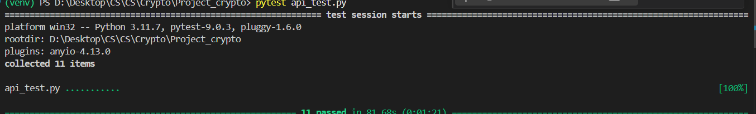

Security Analysis:
The analysis here evaluates the credibility and robustness that the system has in face of various types of threats and attacks and the cryptographic mechanism and algorithms that are implemented in the system in order to deal with these types of attacks. It also deals with how successful those mechanisms that are implemented to prevent attackers in minimizing the attack.
Man-in-the-Middle (MitM) Attack:
In order to deal with man in the middle attacks the system implements hybrid cryptography in which the majority of the data is encrypted using advanced encrypted standard-256 key ,that key is then encrypted using the receiver’s public key and is sent to the receiver ,the receiver uses his private key in order to find the AES 256 key which can then be used to decrypt the data . Assuming that an attacker captures the data they lack the private key that the receiver has in order to decrypt it and to find the AES key or that they need in order to decrypt the data in itself these two layer of authentication and encryption ensures that the threat from the man in the middle attack is minimal.
Password Theft:
In order to safeguard the system from a password threat the Aargon2id algorithm is used which is a unique hashing algorithm which uses the concept of hashing and salting and because it is a memory hard function that is specifically designed so that it resists the parallel computing ability of some attacks and brute force attacks, the algorithm ensures that the attacker cannot decrypt it by using the brute force mechanism or any other mechanism by making it mathematically impossible to decipher unless key is known.
Message & File Tempering:
So the system operates on an concept of encrypt then verify that means that the system ensures that the file and the message is bound to integrity proof during the download phase the system does an SHA 256 integrity check on the plaintext and then verifies the AES tag and if the data was it means it is corrupted and that is written in the fileaccesslog for audit purposes.

Conclusion:
In conclusion we can say that the secure examination management system provides A robust architecture for protecting the important and the sensitive documentation and information by implementing a hybrid encryption architecture by using advanced encryption standard and RSA.
We separated the departments & scanning for threats on the system and using advanced password protection we made sure that the system keeps sensitive data safe from unauthorized access. This provides a reliable, long term solution for handling sensitive university documents online.

TECH STACK & Algorithams:
Libraries:
Here is the list of libraries used across your project:
- fastapi
- sqlalchemy
- alembic
- pydantic
- pydantic-settings
- streamlit
- requests
- pycryptodome (imported as Crypto)
- python-jose
- argon2-cffi
- python-magic
- anyio
- pytest
- python-multipart
- uvicorn

STACK:
- Backend Framework: FastAPI
- Frontend Framework: Streamlit
- Database: SQLite
- ORM: SQLAlchemy
- Database Migrations: Alembic
- Database View: DBEAVER
- Language: Python
- Cryptography: PyCryptodome (RSA, AES,SHA)
- Authentication: JWT with Argon2id hashing

Algorithams:
AES-256: Used as the primary encryption algorithm for the majority of data and it is the industry standard for secure data encryption
RSA-3072: Used for asymmetric cryptography to securely transfer the AES keys from the sender to the receiver because AES keys cannot be transmitted and transferred over an open network this algorithm is used to wrap the AES key by using the recipient’s public key.
SHA-256: This is used for the data integrity verification the system calculates the hash of the file and then uses it to confirm that the data has not been tampered with or modified or corrupted during transfer
Argon2id: this was used in in order to hash the passwords and unlike standard and previous hashing algorithms this uses hashing and sorting techniques which makes it highly secure and it can’t be brute forced/

ARCHITECTURE:

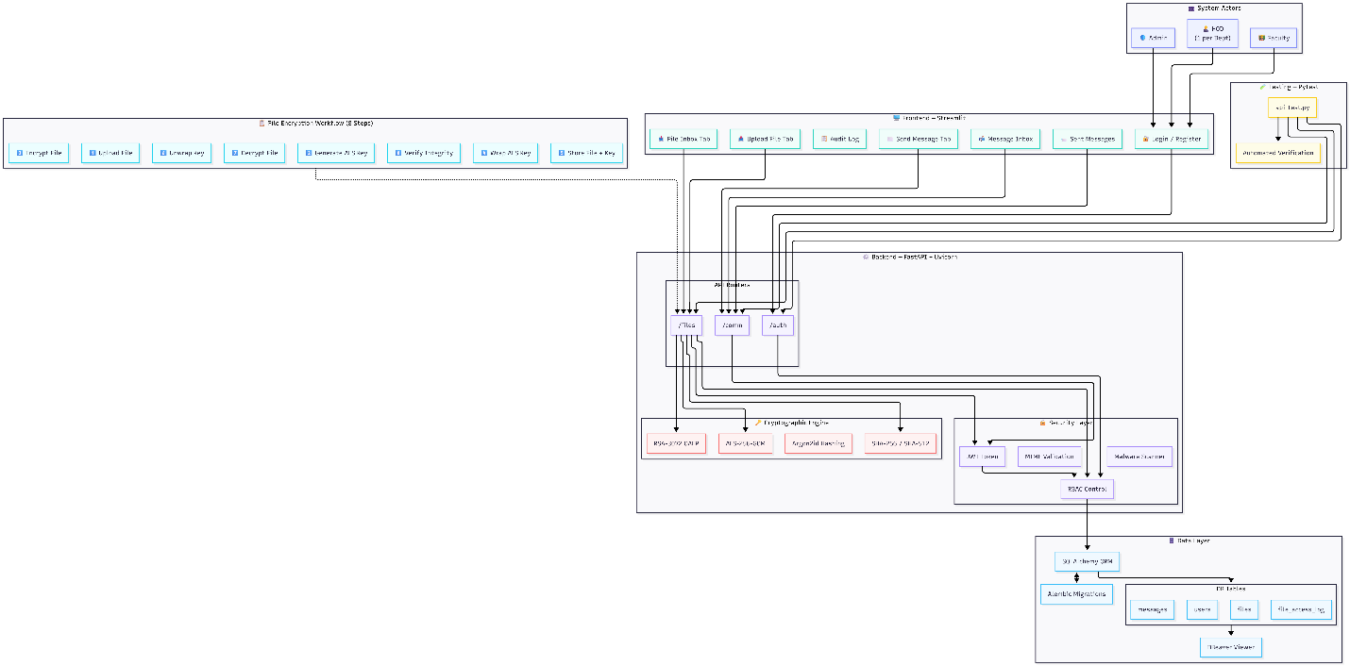

Screen Shots:
